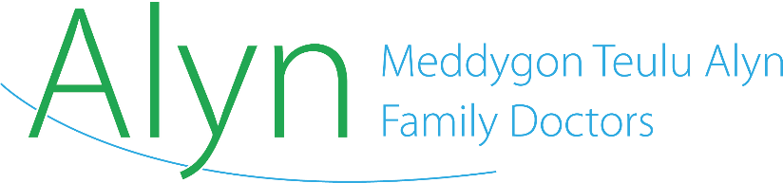

Policy | Governance arrangements for eConsult and email appointment requests
Author | Practice Manager
Date | 01/06/2021
Review due | 01/06/2022

Triage policy and governance arrangements for Klinik and email appointment requests

Emailed requests

The practice does not accept emailed requests from patients. All emails to the general enquiries inbox receive an automated bilingual response to inform them they should direct urgent requests for medical attention to our reception team by telephone or non-urgent requests via our digital Klinik system for triage.

In addition, reception should consult the ‘Standard Responses’ Word document on the shared folder to send a personalised reply to the patient. In exceptional circumstances and using their best judgment, reception staff should telephone a patient to direct them towards care, e.g. if ‘red flag’ symptoms are raised in the email.

Email requests are accepted from other health and social care agencies and should be triaged by a GP before being allocated an appointment.

Automated response

***THIS IS AN AUTOMATED RESPONSE***

This email address is for general enquiries and prescription requests only. If you require an urgent response, please ring 03333 323260 to speak to a member of our reception team. We aim to respond to your e-mail within 72 hours.

To request an appointment, please use our digital Klinik system via our website: www.alynfamilydoctors.co.uk (8am to 12.30pm) or call our Patient Advisors on 0333 332 3260. All appointment requests are triaged by the system and you can use this to request an advanced appointment.

Noder fod y cyfeiriad e-bost hwn ar gyfer ymholiadau cyffredinol a phresgripsiynau yn unig. Os oes angen ymateb ar frys arnoch, ffoniwch 03333 323260 i siarad ag aelod o'n tîm derbyn. Anelwn at ymateb i'ch e-bost o fewn 72 awr. Mi wnawn ein gorau i ymateb yn eich dewis iaith, ond gan fod nad yw pob un o'n tîm yn medru siarad Cymraeg, byddem yn ddiolchgar pe byddech yn amyneddgar os byddwn yn ymateb yn Saesneg ar adegau.

I archebu apwyntiad, defnyddiwch ein system digidol Klinik ar ein gwefan: www.alynfamilydoctors.co.uk (8am i 12.30pm) neu ffoniwch ein Cynghorwyr Cleifion ar 0333 332 3260. Bydd pob cais yn cael eu brysbennu gan ein system; gallwch ei ddefnddio i ofyn am apwyntiad

Klinik requests

All GP appointment requests, whether for urgent, routine or pre-bookable appointments, are submitted via Klinik. Digital requests can be submitted between 8am and 12.30pm, and telephone requests from 8am to 6.30pm (emergency calls only advised after 5pm).

Digital Klinik requests are received daily between 8am and 12.30pm and are triaged automatically by the AI system and are double-triaged before 4pm by a GP. All requests for a child aged 16 or under are flagged by the system.

A GP will indicate on the triage system the appropriate timescale for an appointment, with children aged 16 and under with acute presentations being prioritised for a same-day consultation.

Reception must screen all incoming non-urgent requests to ensure that any for a child aged 16 or under are placed before a GP for triage that day if not otherwise flagged.

Triage
The Klinik system uses artificial intelligence to assign an urgency rating for an appointment request. These ratings are overseen by a GP who may amend the rating.

Patient Advisors then contact the patient to negotiate a suitable time for an appointment within the timescale of the urgency rating.

All triaged requests with an urgent rating, or triaged requests for children aged 16 and under with urgent/acute presentations should be prioritised for an appointment within 24 hours.

